Network Management and Automation

Lab 6

DevOps - Ansible

University of Colorado Boulder

Network Engineering Program

Professor Levi Perigo, Ph.D.

Summary

Ansible has proved to be profoundly different from other configuration management tools available today, and is prevalent in industry for managing and configuring network devices as well as servers. It has been designed to make configurations easy in almost every way. Some of its notable features include its simple English configuration syntax, agentless running service, and its ease of setup.

# Objectives

* Configuring and installing Ansible.
* Learn to use Playbooks for configuration management.
* Learn how to perform package management on the hosts.
* Learn how to perform identity and access management.

* Learn to perform file transfers and directory management.

Problem Statement

Liverpool and Real Madrid have a strong history of European Football. The two teams have once again made their way to an epic Champions League final. The FIFA administration has been entrusted the job to ensure that all things are in place to give us a thriller.

You will be acting as the FIFA administrator and be performing the tasks given below.

# Objective 1 – Setting up a Virtual Network

# 

**Figure 1**

1. Create the above network of three virtual machines (use the NetMan VM as the FIFA_admin, which will act as the Ansible Server) in VMWare Workstation.

We have assigned 2 additional VMs in Vsphere for you to use. You should be able to see these VMs once you login to vsphere

OR

You can use any Linux based OS of your choice to spawn the Liverpool and Real Madrid virtual machines. You can use the Ubuntu 16.04 Desktop image as the OS (<https://releases.ubuntu.com/16.04.7/>). Liverpool Internal Network- liverpool-192.168.10.1 and netman-192.168.10.2. Realmadrid Internal Network - realmadrid-172.16.10.1 and netman-172.16.10.2

1. Provide screenshots of successful network connectivity (ping between netman and Liverpool, and netman and realmadrid). **[10 Points]**

Liverpool:

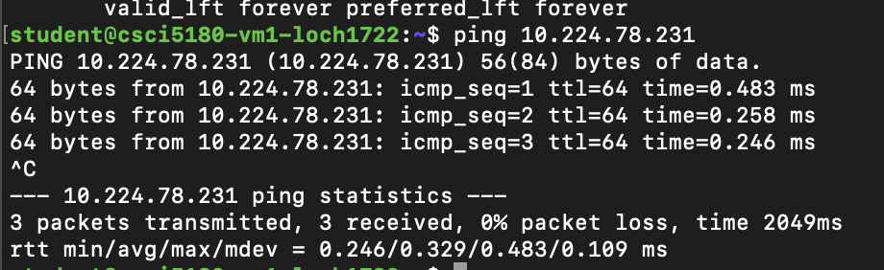

Real Madrid:

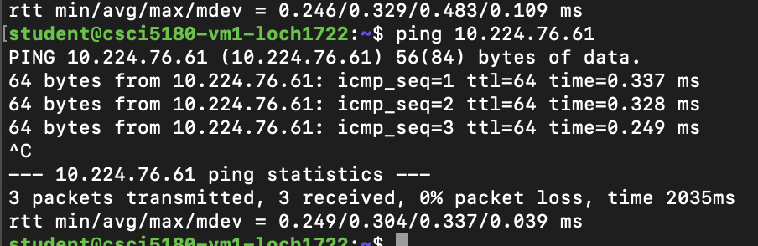

# Objective 2 – Installing Ansible

1. Issue the “**ansible --version”** command to check if ansible is present in FIFA_admin. If not, install it using pip3. Provide screenshot of the output. **[5 Points]**

I installed ansible using ‘pip3 install ansible’. Screenshot for ansible –version:

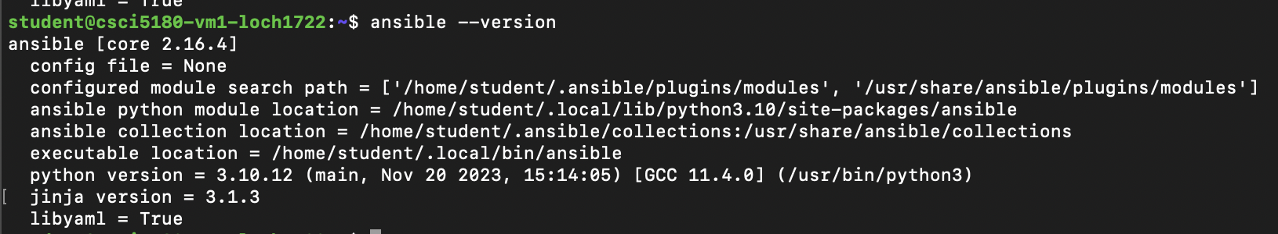

1. In order to allow FIFA_admin to control the two hosts through a playbook, ensure that you add the hosts in the /etc/ansible/hosts or any other Inventory file of your choice (<http://docs.ansible.com/ansible/intro_inventory.html>). Ensure connectivity between the server and managed hosts using the “**ansible all -m ping --ask-pass**” command. Provide screenshot of the output. **[5 Points]**

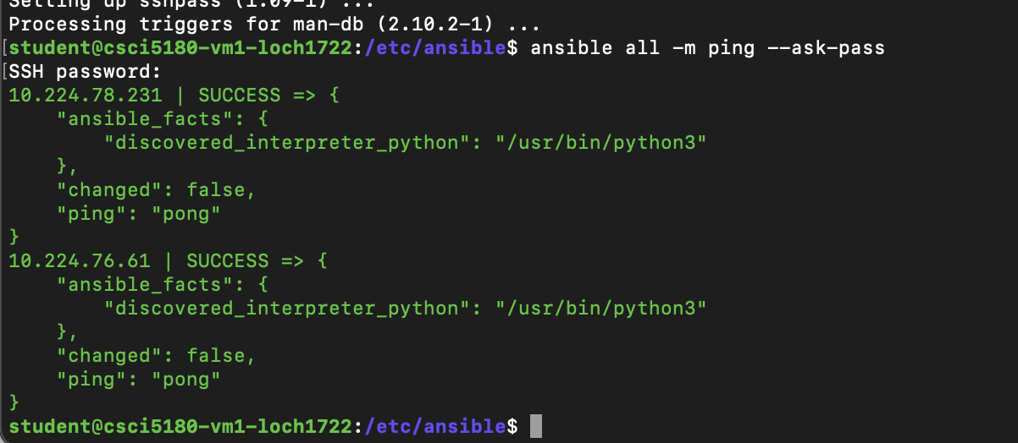

Objective 3 – Creating a Centralized Playbook

The following objectives need to be accomplished by creating a **single** playbook on the FIFA_admin machine. The playbook file should be named as “YourIdentiKey_play.yml”. Make sure you give meaningful names to the tasks performing the below objectives in the playbook.

Objective 3.1 – Installing Packages

1. Liverpool and Real Madrid machines should have FTP and HTTP capabilities. Additionally they need pip and expect packages. Install all these essential packages through the playbook on FIFA_admin (use [loops](http://docs.ansible.com/ansible/playbooks_loops.htm) to perform the repetitive installation tasks).

**[10 Points]**

Screenshot below. Script is also submitted via canvas:

1. Provide screenshots of the relevant portion of the playbook and the successful package installation on the two nodes. **[10 Points]**

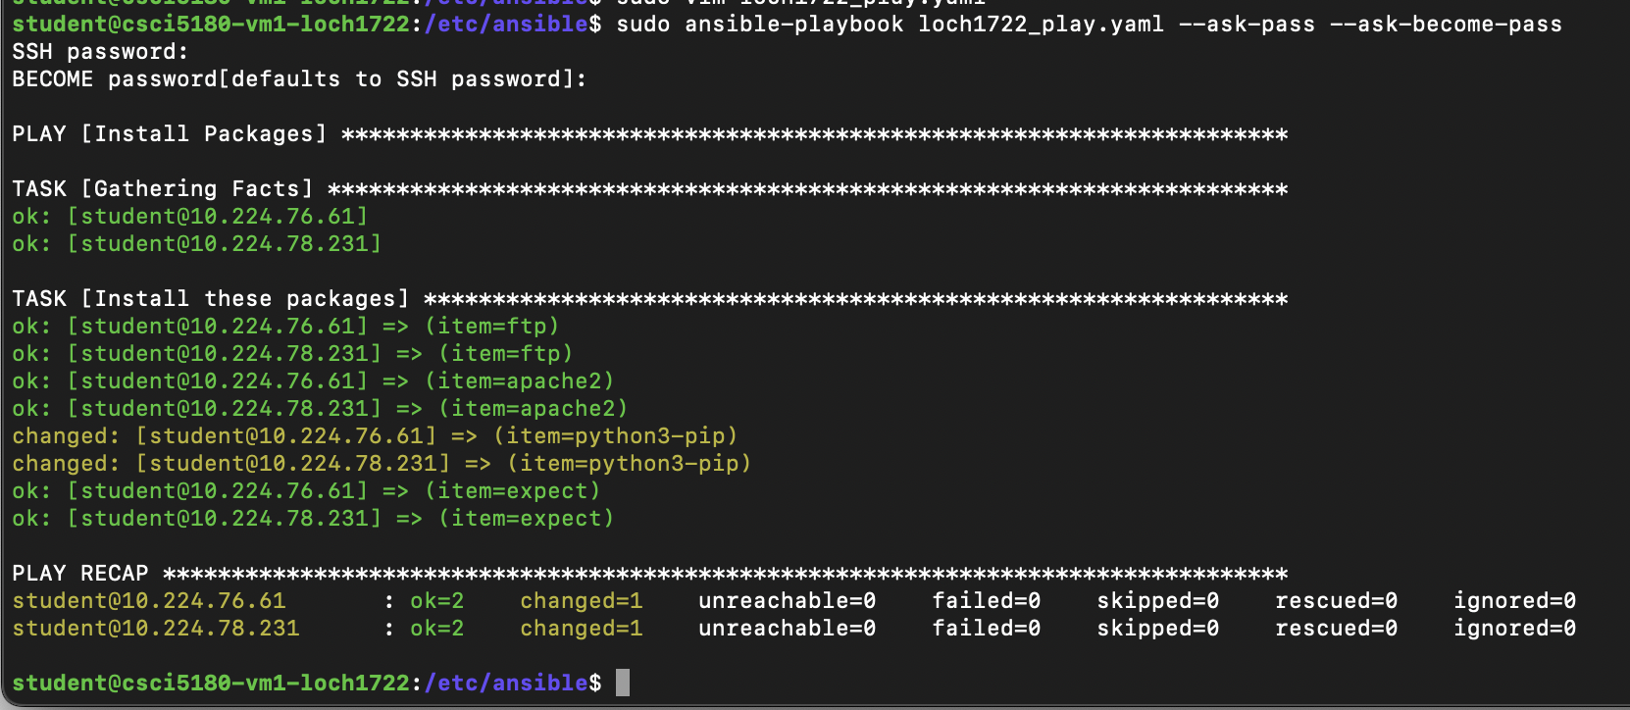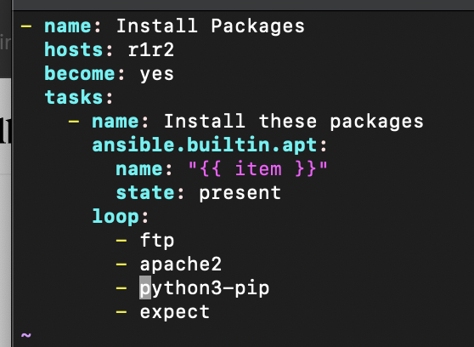

Objective 3.2 – Creating Users, Groups, and Permissions

1. Create users and groups on the managed hosts using the same playbook on the control machine. **[5 Points]**

Screenshot below. Script is also submitted via canvas:

1. The three groups on each machine are: Attack, Defense, and Captain. The users to be created, their corresponding groups, and permissions are mentioned in tables below. The users should be created with the naming format of FirstInitialLastName (for example Harry Kewell’s user name would be hkewell). **[15 Points]**

Screenshots are provided below under 3.3

**Liverpool**

|  |  |  |
| --- | --- | --- |
| **User** | **Group/Groups** | **Group Permissions** |
| Harry Kewell | Attack | rw-rw-rw |
| Michael Owen |
| Jamie Carragher | Defense | --x--x--x |
| Daniel Agger |
| Steven Gerrard (present in two groups) | Captain and Any group with highest access permissions (Eg: Wheel) | rwxrwxrwx |

**Real Madrid**

|  |  |  |
| --- | --- | --- |
| **User** | **Group/Groups** | **Group Permissions** |
| Luis Figo | Attack | rw-rw-rw |
| Roberto Soldado |
| Roberto Carlos | Defense | --x--x--x |
| Fabio Cannavaro |
| Zinedine Zidane  (present in two groups) | Captain and Any group with highest access permissions (Eg: Wheel) | rwxrwxrwx |

1. Provide screenshots of the relevant portion of the playbook, successful creation of all users and their group permissions. **[5 Points]**

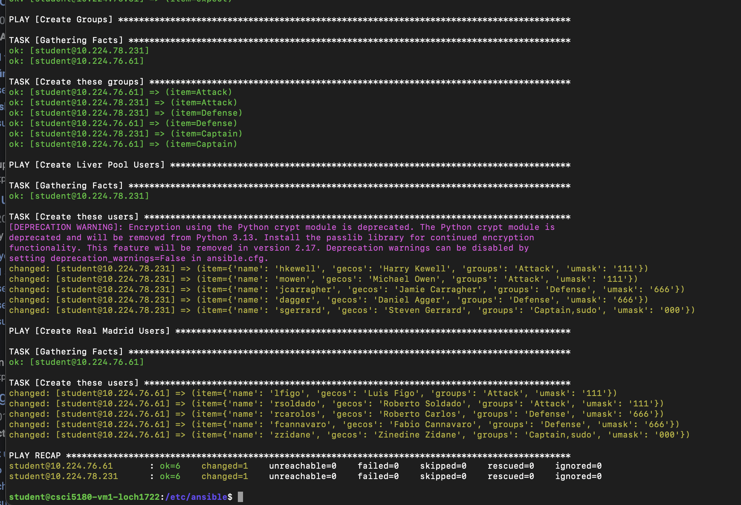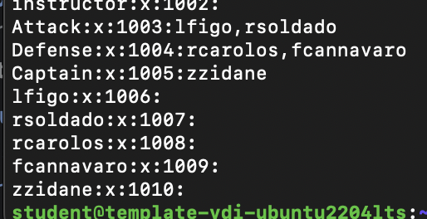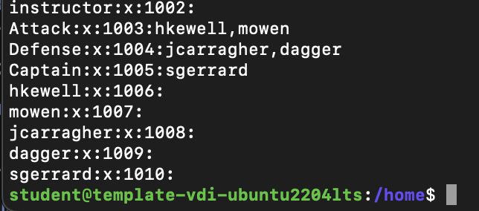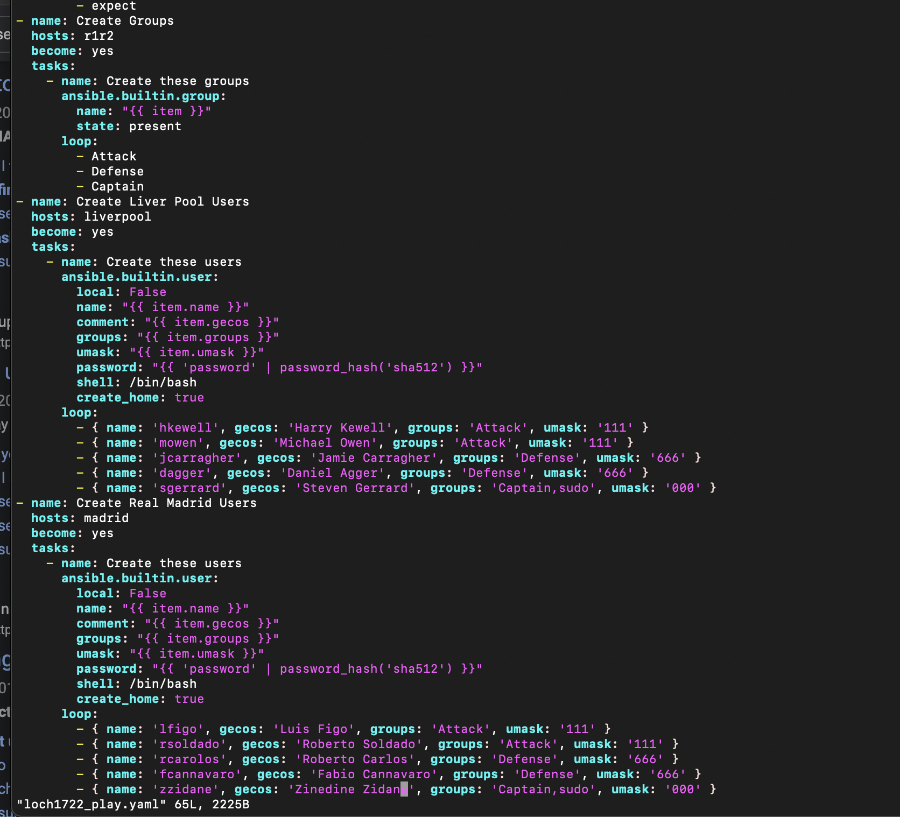

Objective 3.3 – Creating Files and Directories

1. Add commands to the same playbook to create directories on Liverpool and Real Madrid which will be used to store route table information in the next objective. The directory should be created in the path /MachineName_Admin/Route_Info/. The owner and group owner for this directory should be Captain, and they should have all permissions. Users who are not in the Captain group should have read-only access to this directory.
2. Provide screenshots of the relevant portion of the playbook, successful creation of the directory and applied permissions. [**10 Points**]

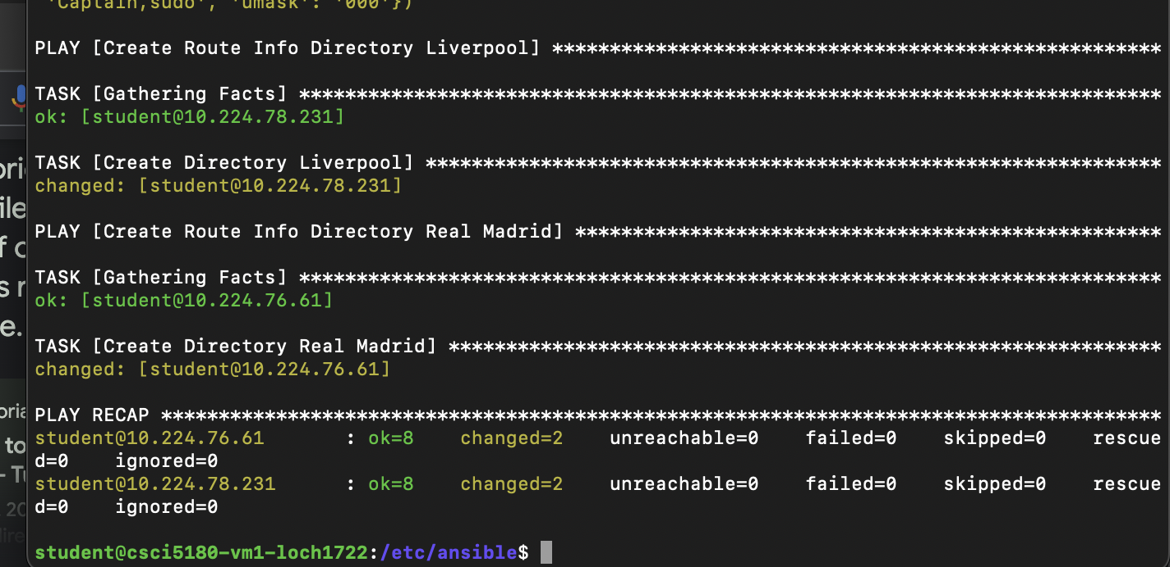

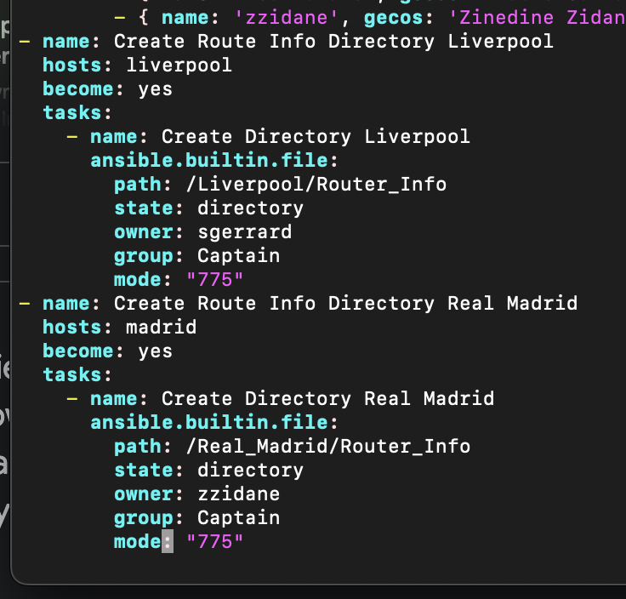

Liverpool:

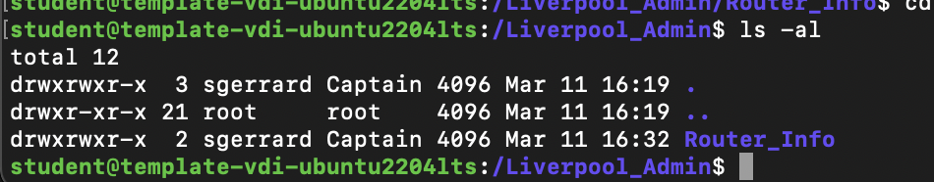

(I gave exec permissions so that users could access the directories)

Real Madrid:

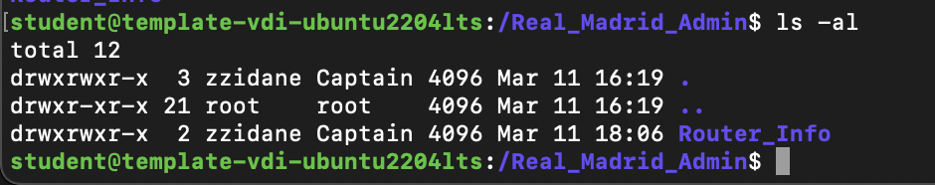

1. On each host, create a file Captain_Details.txt under the above created directory and store the captain information (full name, nationality, username) using the same playbook. Provide relevant screenshots. [**10 Points**]

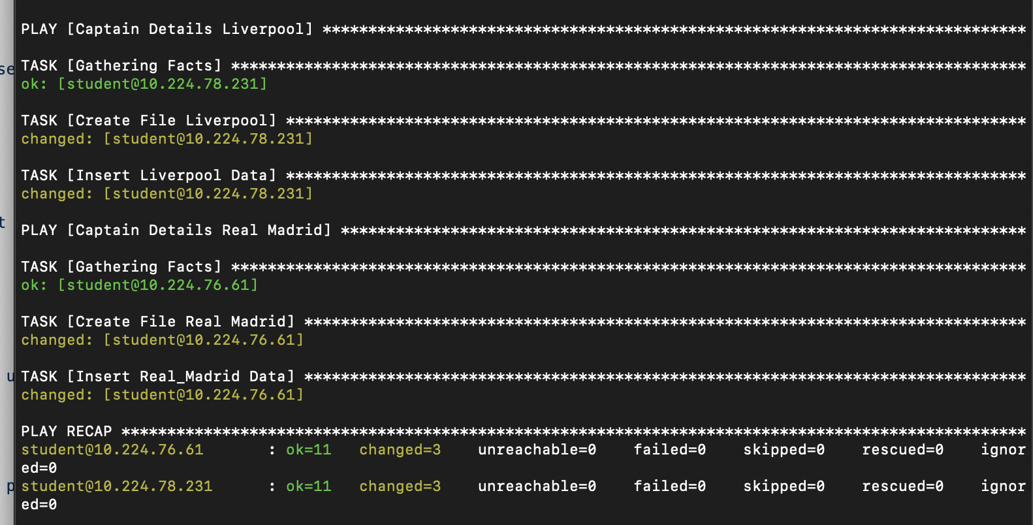

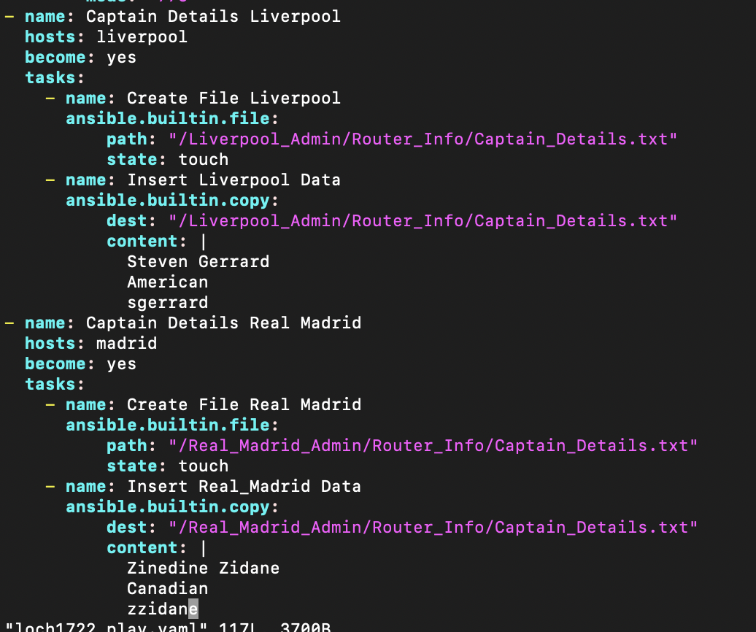

Liverpool:



Real Madrid:

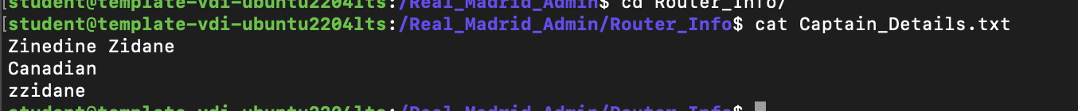

Objective 3.4 – Executing Shell Commands, Performing File Transfer

1. The FIFA_admin machine needs to request route table and top ten running processes (based on memory usage) from the managed hosts. Add functionality in the playbook to do the following:
2. Execute shell commands (hint: netsat , ps ) to retrieve the required information and store it in two different files. **[10 Points]**

Screenshots are shown in 3.4.2

1. Perform secure transfer of these files from host to FIFA_admin using **SCP** commands. Use the **expect** module to enter password and any other information associated with SCP when prompted. Passwords and prompts should not be handled manually but through the playbook. **[15 Points]**

Screenshots are shown in 3.4.2

1. Provide screenshots of the relevant portion of the playbook and successful file transfer.

**[5 Points]**

3.4a:

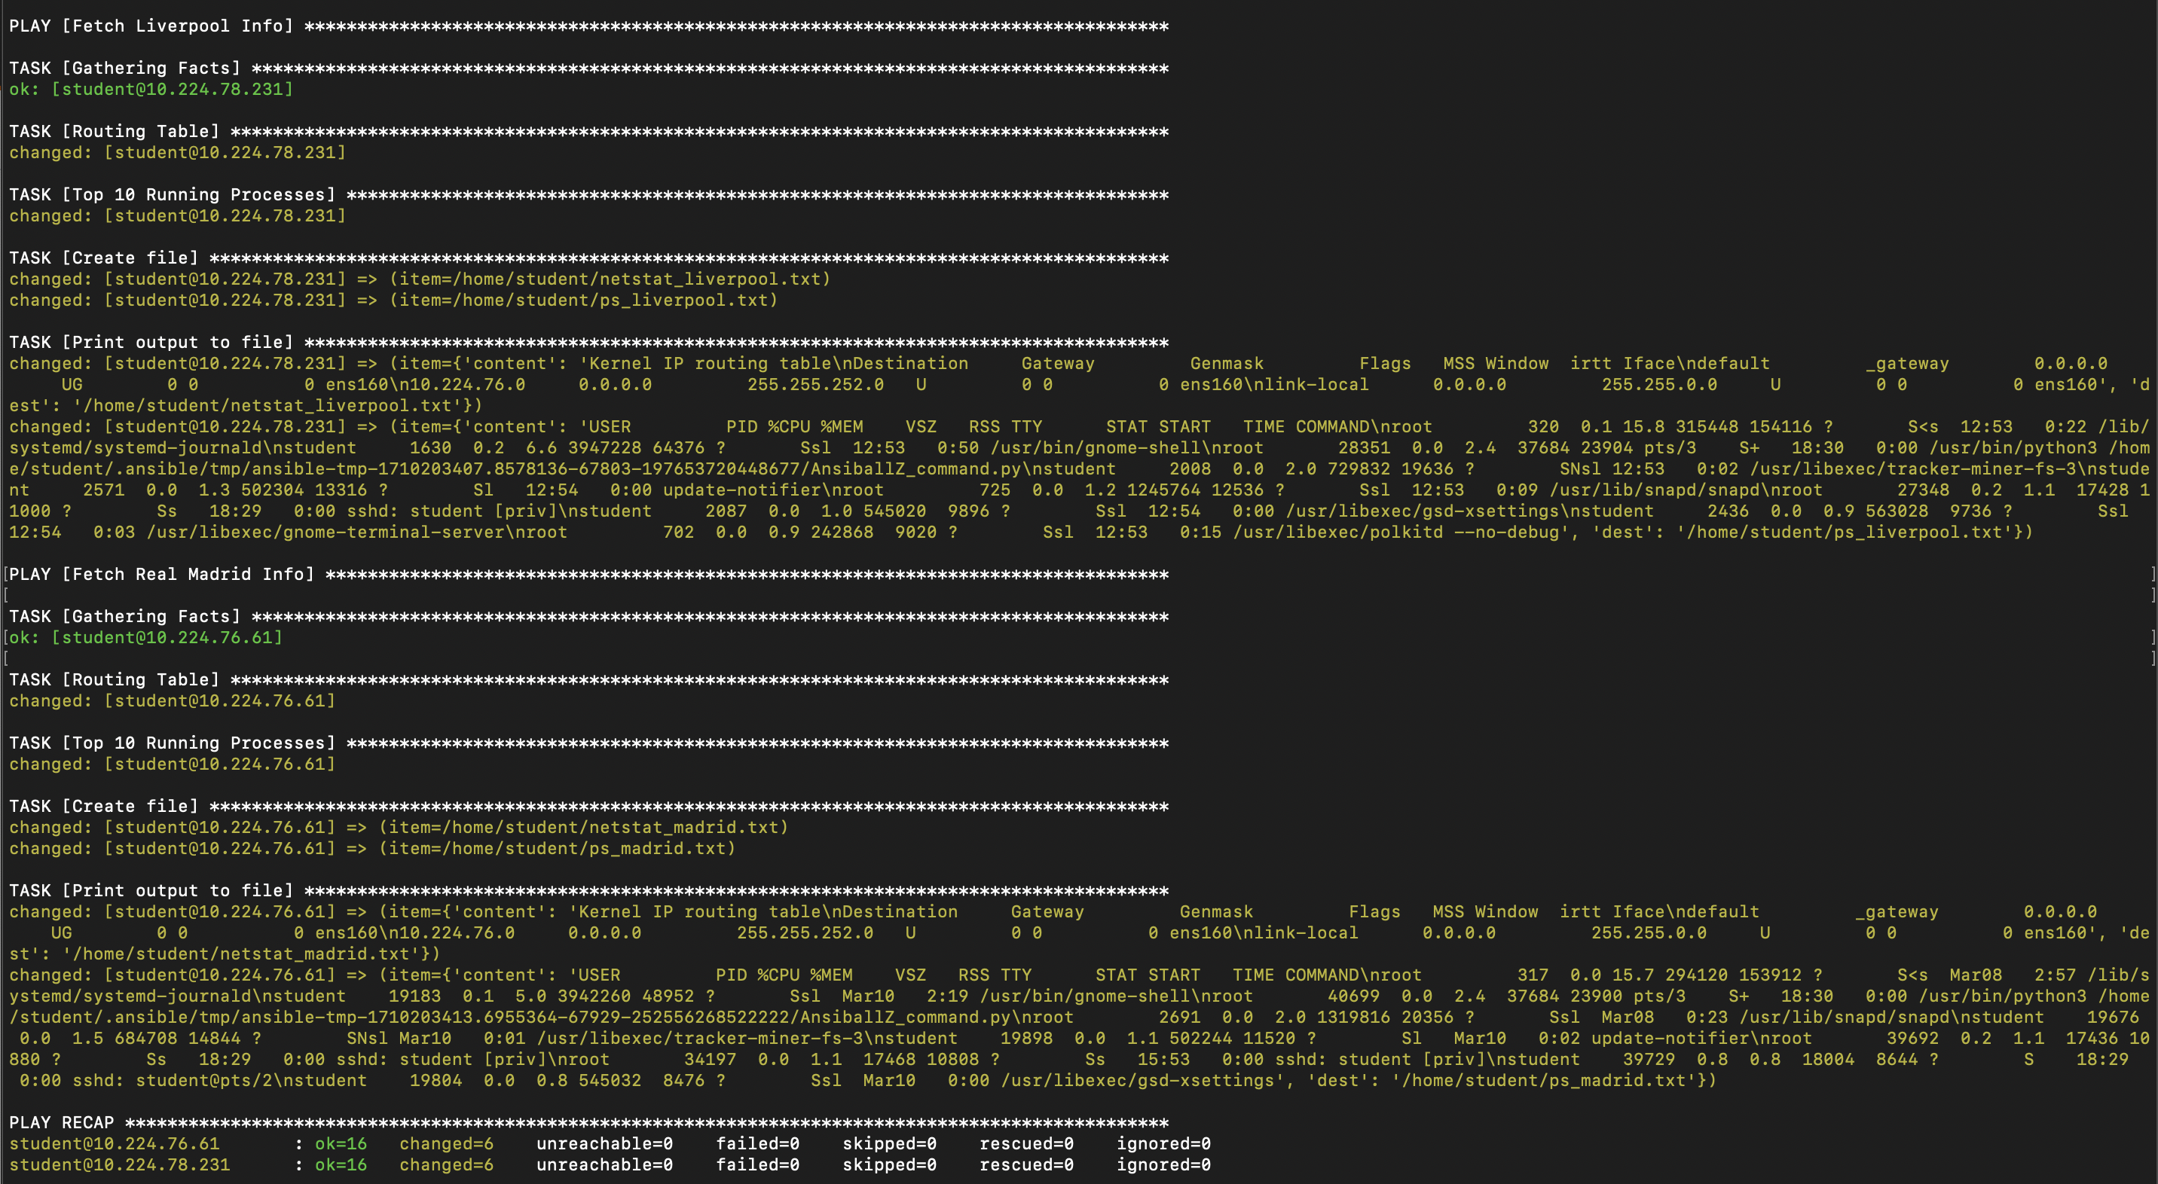

3.4b:

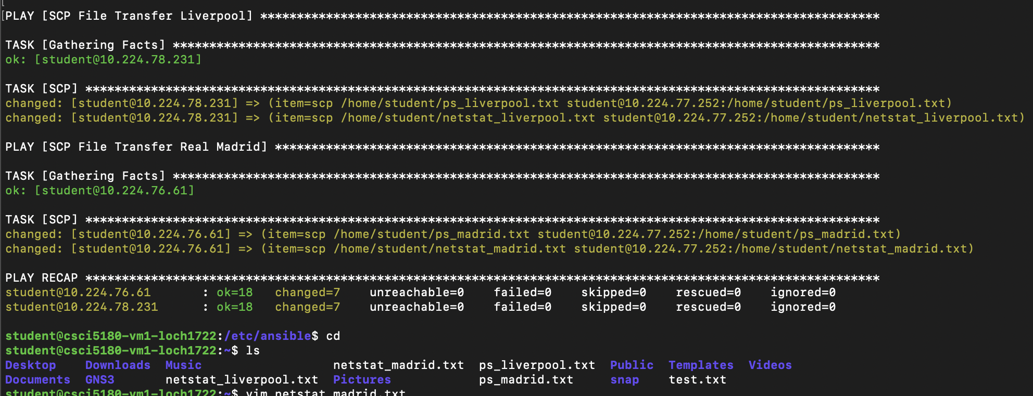

Examples of netstat and ps files:

Real Madrid:

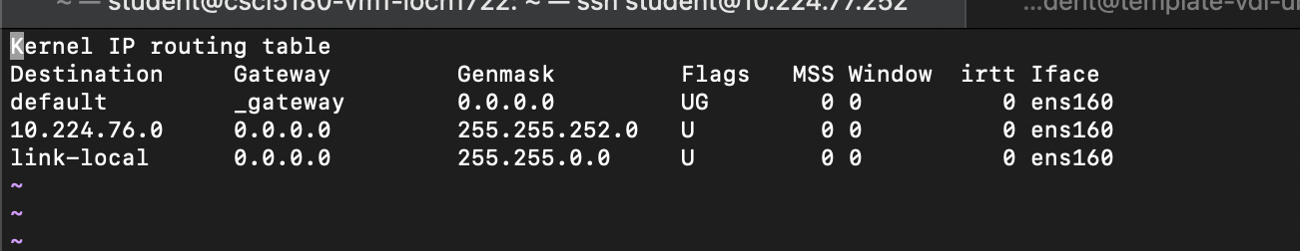

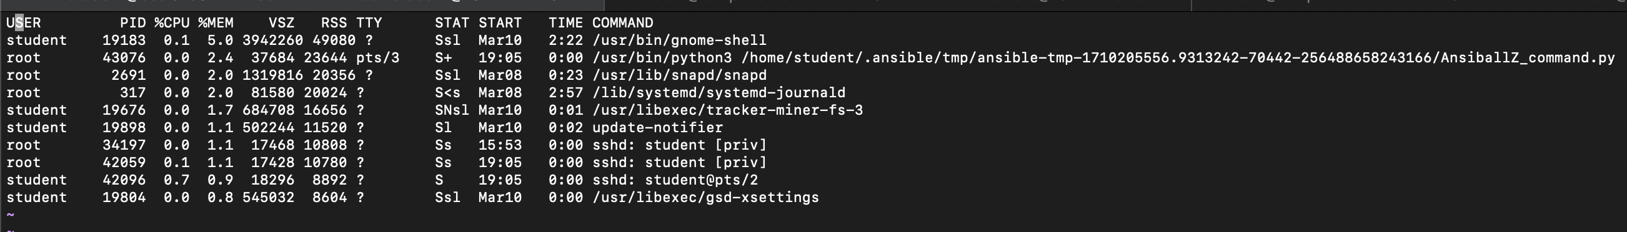

Liverpool:

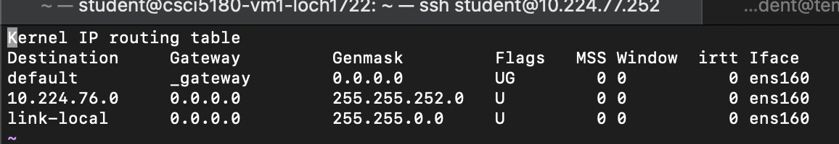

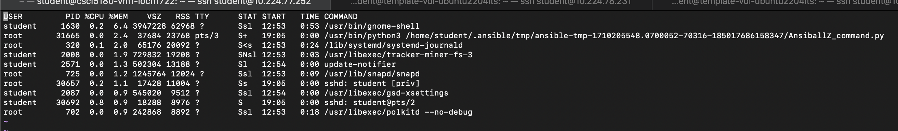

Playbook code for both 3.4a and 3.4b:

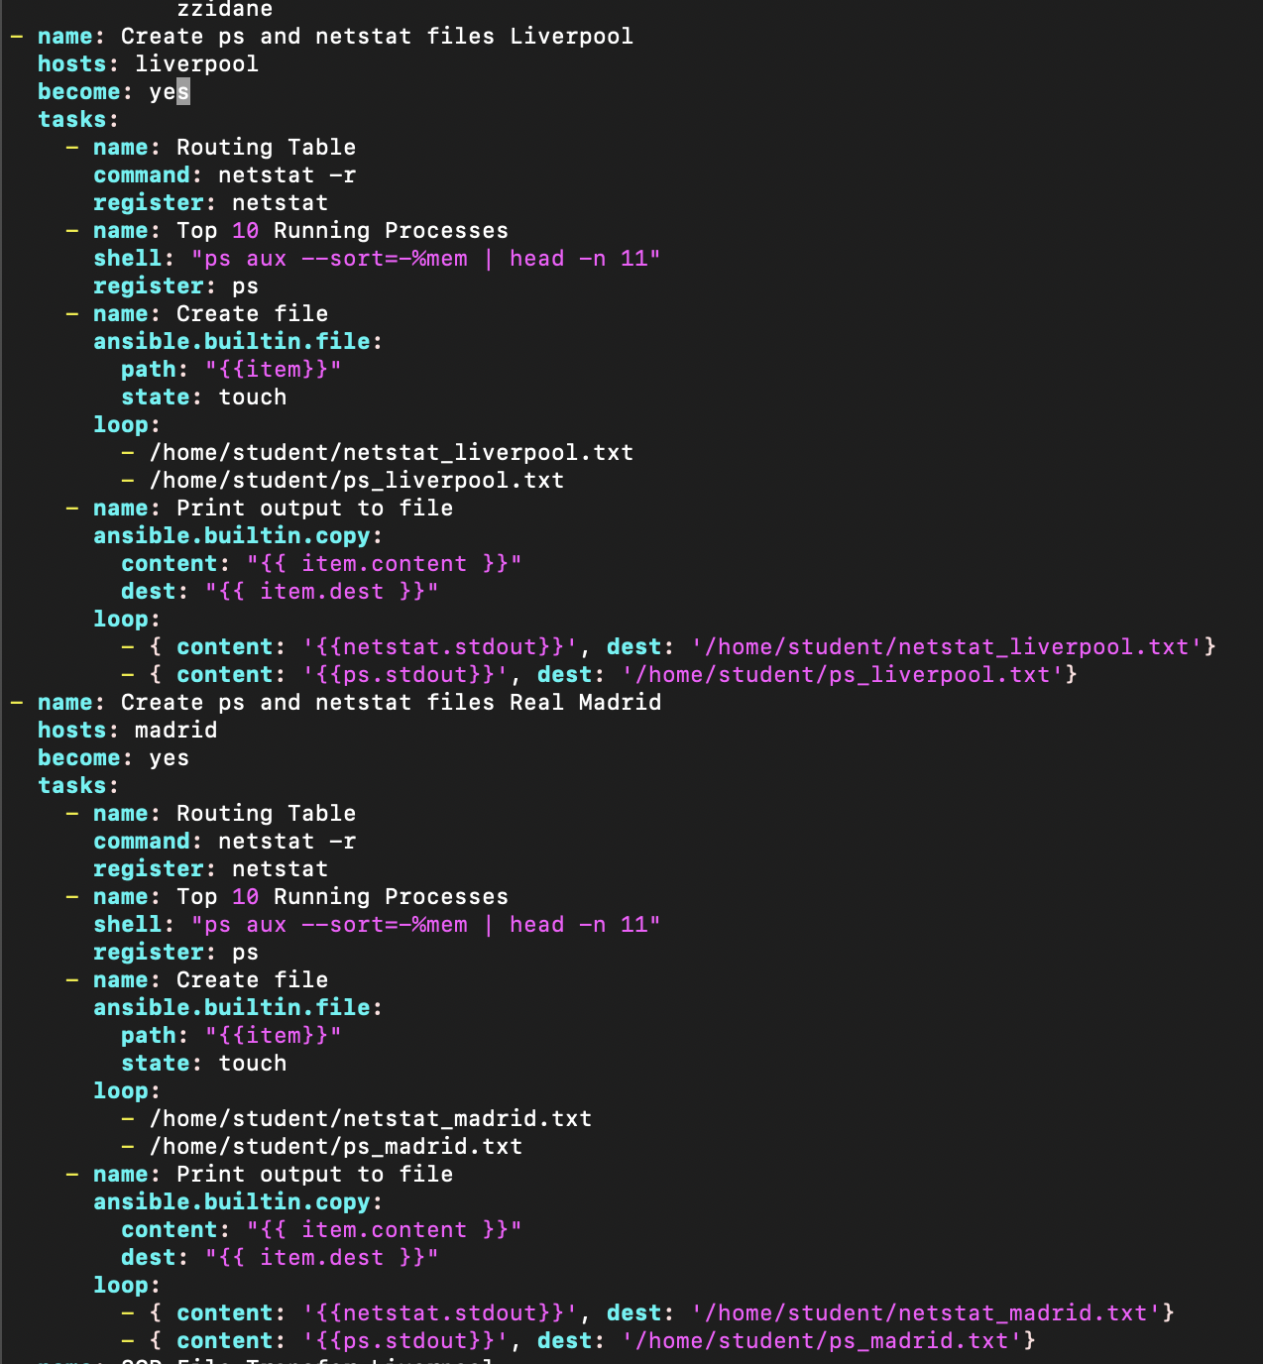

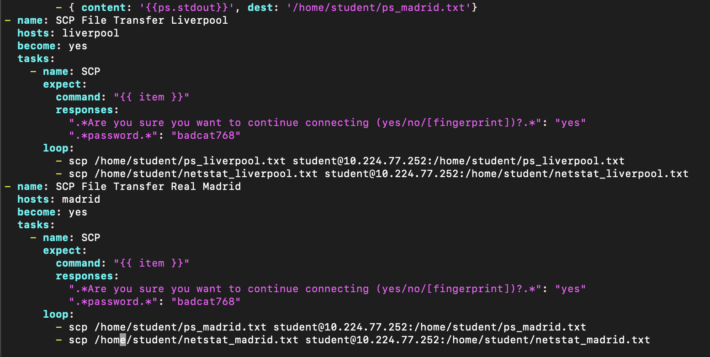

Objective 3.5 – Combining multiple files into a single file

1. Manually generate SSH keys for the following players on their local machines: **[5 Points]**
   1. **Liverpool b. Real Madrid**

Michael Owen Luis Figo

Daniel Agger Fabio Cannavaro

Steven Gerrard Zinedine Zidane

This was done by going into each user by issuing the command: su ‘name’

I then typed the command ‘ssh-keygen’ and pressed enter until it was created. Here is an example of Michael Owen doing it:

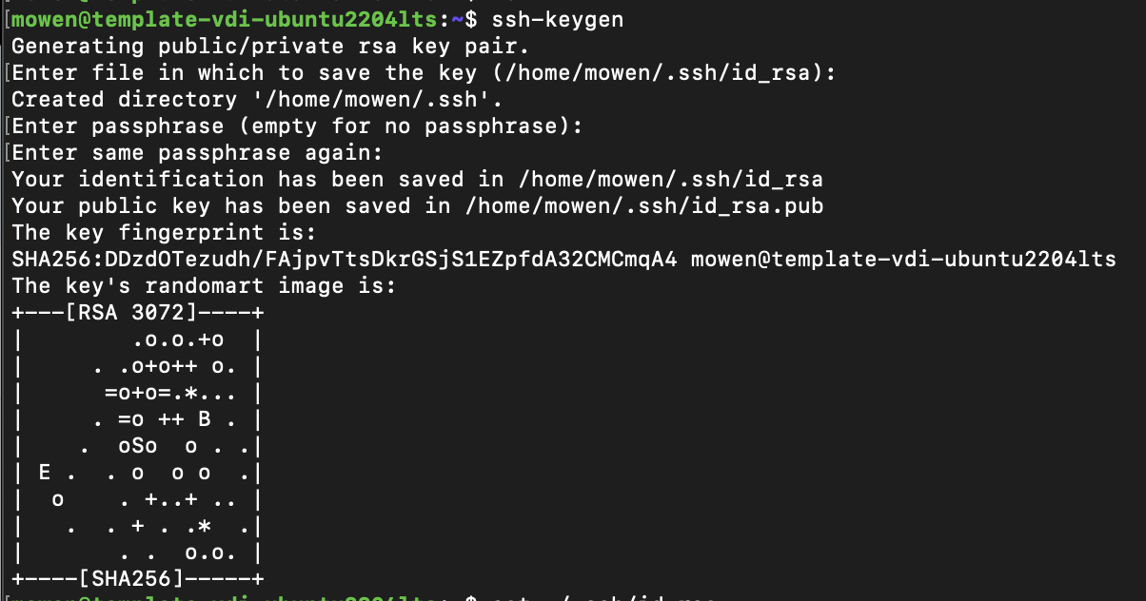

1. In the same playbook, use the [assemble](http://docs.ansible.com/ansible/assemble_module.html) module of Ansible to combine the public keys( .pub) for the above players into a single file on the host machine named as TeamName_authorizedKeys.txt and store the file in the .ssh directory of the root user. (eg. Liverpool_authorizedKeys.txt will have public keys of the three Liverpool players and will be stored in the root user’s .ssh directory on the Liverpool machine.)

**[10 Points]**

Screenshots are below at 3.5.4

1. Using the playbook, send these files to the FIFA_admin machine and store them in the root user’s .ssh directory. **[10 Points]**

Screenshots are below at 3.5.4

1. Provide screenshots of the relevant portion of the playbook and the files in the .ssh directory of the root user of FIFA_admin machine. **[5 Points]**

3.5.2 screenshots:

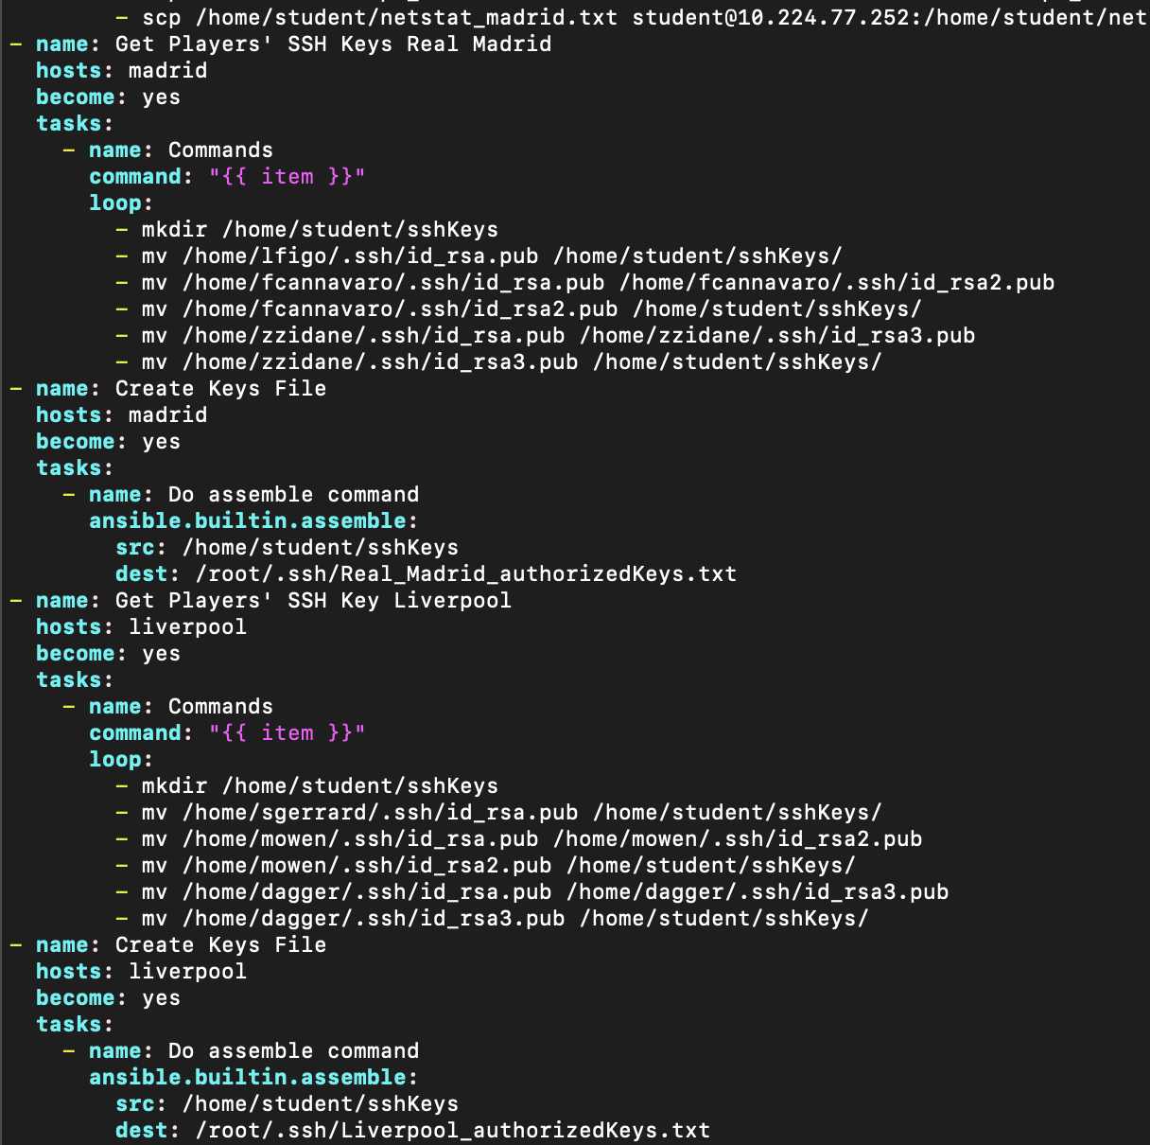

Liverpool keys screenshots:



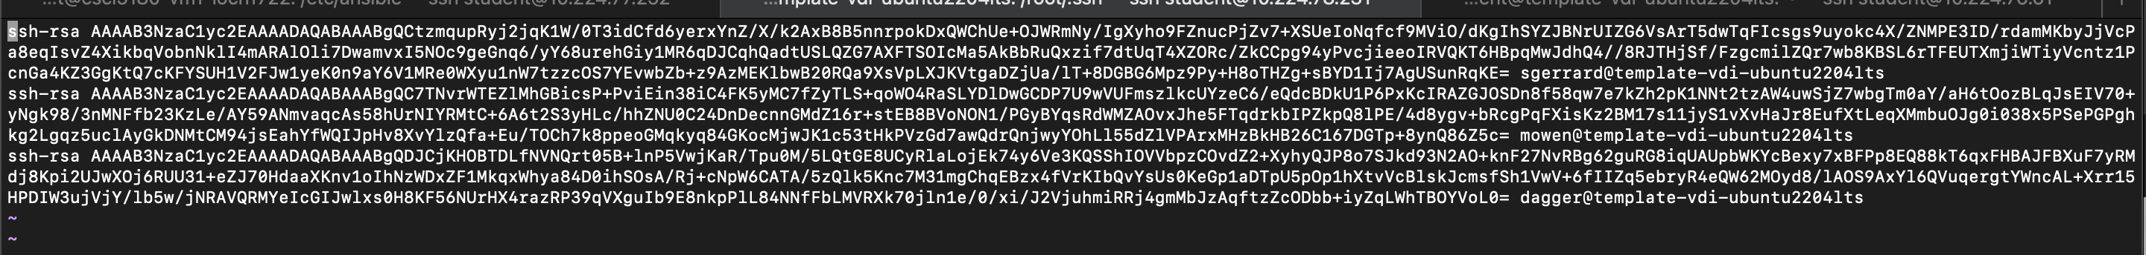

Real Madrid keys screenshots:



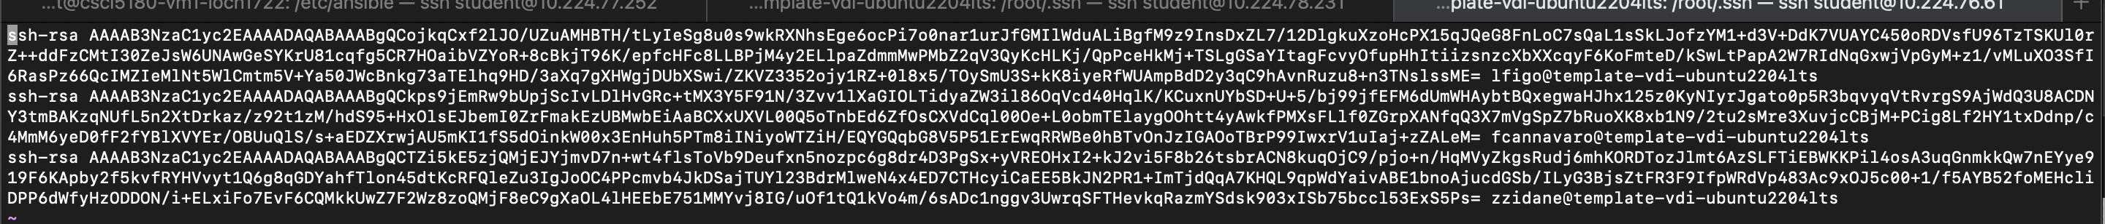

3.5.3 screenshots:

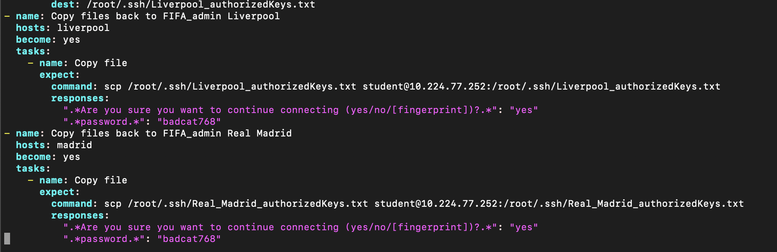



Objective 4 – Extra Credit - Ansible Additional Server Configuration and Router Configurations

Part 1 (Using additional modules in Ansible)

1. Create two more playbooks named as LiverpoolManager.yml and RealMadridManager.yml
2. Think of a use case that will make use of the following Ansible modules in the respective YAML files: **[10 Points]**

|  |  |
| --- | --- |
| **File** | **Modules to use** |
| LiverpoolManager.yml | group_by, wait_for, set_fact |
| RealMadridManager.yml | template |

1. Once you are done executing the above YAML files separately, think of executing all the above tasks via a single playbook that you created for this lab (YourIdentikey_play.yml)

**[5 Points]**

Part 2 (Router configuration via Ansible)

1. Construct the same topology done in Automation 1 and configure IBGP between the routers by passing commands through Ansible playbook. It is not required to use multithreading in this case. **[15 Points]**

Total Points ____________ / 175